eWEEK OpenHack IV – Oracle Solution Information
Oracle9i R2 RDBMS and Oracle9iAS R2
John Abel, Oracle UK Consulting (john.abel@oracle.com)
Ian Bryson, Oracle UK Consulting (ian.bryson@oracle.com)
Project Overview

eWeek Labs requested Oracle Corporation’s participation in their fourth annual OpenHack competition, designed to test enterprise security by exposing systems to the real-world rigors of the Web. Oracle Corporation took an eWeek application and migrated it to an Oracle9iAS R2 J2EE environment, using only Oracle components (e.g. Oracle9i RDBMS R2 and Oracle9iAS R2). Some changes have been made to make the application even more secure and resilient to penetration attacks. The following are topics covered in this paper:

- Database changes (migrate from IBM DB2 to Oracle9i RDBMS).
- Application changes (migrate IBM Specific application to Oracle9iAS J2EE application).
- Document hardware configuration recommended for OpenHack.
- Document software configuration changes.
- Identify other enhancements that have been made to the application to enhance the security.

Audience

The following information should be used in conjunction with Supplier specific install and configuration document. It is assumed that the person(s) using the following notes is fully aware of the following products:
- Red Hat Advanced Server 2.1.
- Oracle9iAS Release 2.
- Oracle9i RDBMS Release 2.

Figure 1 explains the key components to the solution; all components are explained in more detail within this document.

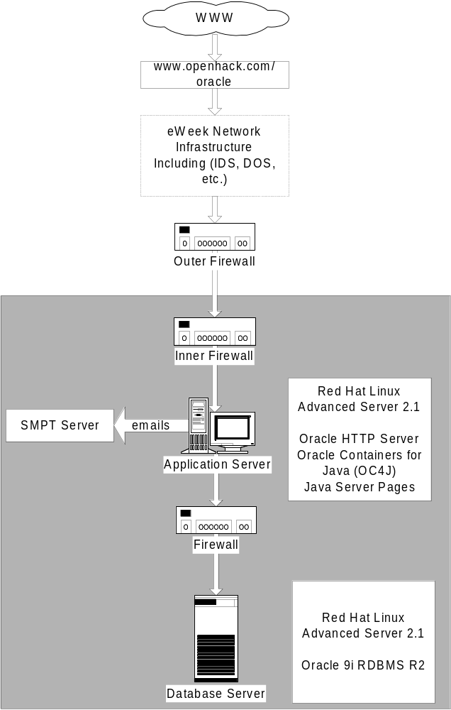
Figure 1

Database Changes

The following changes have been made to the eWeek scripts to migrate them from IBM DB2 to Oracle9i RDBMS. In addition, some changes have been added to enhance the script.
Script name : create_awards_db_20020327 (DB2).sql (new name create.sql)

DB2 Script | Oracle Script “Change”
CONNECT TO AWARDS | The following was added so the script is run as SYSTEM/MANAGER.  CONNECT SYSTEM/MANAGER
Add some Oracle Specifics to create the users. | The following command will drop the users if they exist already  DROP USER EXADMIN CASCADE;  DROP USER JUDGE CASCADE;  DROP USER WEBUSER CASCADE;  Grant connect and resource roles to the three core users. Each user has a default password that is changed later.  GRANT CREATE SESSION,  CREATE SEQUENCE,  CREATE SYNONYM,  CREATE PROCEDURE,  CREATE TABLE,  CREATE TRIGGER  TO EXADMIN IDENTIFIED BY EXADMIN;  GRANT CREATE SESSION,  CREATE SEQUENCE,  CREATE SYNONYM,  CREATE VIEW  TO JUDGE IDENTIFIED BY JUDGE;  GRANT CREATE SESSION,  CREATE SEQUENCE,  CREATE SYNONYM,  CREATE VIEW  TO WEBUSER IDENTIFIED BY WEBUSER;  ALTER USER EXADMIN QUOTA UNLIMITED ON USERS;  Set the users default Tablespace and the sort Tablespace for temporary segments.  ALTER USER EXADMIN DEFAULT TABLESPACE USERS TEMPORARY TABLESPACE TEMP;  ALTER USER JUDGE DEFAULT TABLESPACE USERS TEMPORARY TABLESPACE TEMP;  ALTER USER WEBUSER DEFAULT TABLESPACE USERS TEMPORARY TABLESPACE TEMP;  Connect to base owner of the objects.  CONNECT EXADMIN/EXADMIN
All VARCHAR data types | Changed from VARCHAR to VARCHAR2 that is Oracle character variable data type.
IN “USERSPACE1”; | Removed the reference to the Tablespace and allowed objects to be created in user default Tablespace.
GENERATED ALWAYS AS IDENTITY (START WITH +1, INCREMENT BY +1 CHAR 20) | Changed from IBM-specific syntax to equivalent Oracle syntax. Used the combination of the following to give the same effect:  - Create a sequence number;  CREATE SEQUENCE RANKINGS_SEQ;  CREATE SEQUENCE COMPANIES_SEQ;  CREATE SEQUENCE CATEGORIES_SEQ;  CREATE SEQUENCE PRODUCTS_SEQ;  - Created four triggers with the following construct;  CREATE OR REPLACE TRIGGER PRE_RANKINGS  BEFORE INSERT ON RANKINGS FOR EACH ROW  BEGIN  SELECT <sequence number>  INTO :new.ID  FROM DUAL;  END;  /
All INTEGER data types | Changed all INTEGER data types to Oracle NUMBER data types.
All “Schema owner”. “Object name” | Removed the “Schema owner”. “Object name” and replaced with just object name
All TIMESTAMP data types | Changed all TIMESTAMP data types to Oracle DATE data types, just incase dates are stored in fields.
All Constraints with the following construct.  ON DELETE NO ACTION  ON UPDATE NO ACTION | Removed the ON DELETE… and ON UPDATE… from constraints. Oracle syntax is different for ON DELETE / ON UPDATE.
All GRANT permissions | Changed all grant permissions from DB2 specific to Oracle specific.

The following script inserts the data into the static tables.
Script name: awards_db_base_data.sql

DB2 Script | Oracle Script “Change”
Connect to awards user exadmin using yoda7958 | Changed to connect exadmin/exadmin that is Oracle code format.
None | Added the following DML statements to the script, so it can be re-run when used for a second time:  delete from judges;  delete from creditcards;  delete from categories;  delete from states;
All INSERT Statements | Added column definitions to INSERT Statements, the following was a before and after change.  Before  INSERT INTO EMP VALUES (…);  After  INSERT INTO EMP (…) VALUES (…);
DEFAULT Clause | Removed DEFAULT clause allowed the database trigger to insert column

Application Code Changes

The following code changes where required to get the OpenHack application to run on Oracle9iAS and Oracle9i R2 RDBMS. There are 3 main reasons for changing the code.
- Security enhancements - required for extra hardening.
- SQL differences – differences between DB2 and Oracle.
- Application server differences – where there were slight differences in the application servers.

JSP File | Changes required | Reason for change | Lines changed
/include/open_db.jsp | JDBC connection creation changed to use connection pooling. This will prevent a possible DOS problem, by restricting the number of JDBC database connections. | Security enhancement | 12, 18-20, 29-38
/include/catch.inc | Actual error message removed so no useful errors are returned to the users (e.g. machine name, used ports, etc). | Security enhancement | 21, 24
/include/functions.jsp | Included new method SMTPize() to prevent scripting attacks in emails. | Security enhancement | 157 – 189
/include/functions.jsp | Change name of SMTP server | Different mailserver used for the production site | 233
accountcreateedit.jsp | DB2 TIMESTAMP converted to Oracle SYSDATE | SQL difference | 226, 240
accountcreateedit.jsp | SMTPize() all email parameters | Security enhancement | 261, 267, 268
accountcreateedit.jsp | Added call to encryption PL/SQL package for credit username and password | Security enhancement | 218
accountdetailsmail.jsp | SMTPize() all email parameters | Security enhancement | 96, 102, 103
companycreateedit.jsp | DB2 TIMESTAMP converted to Oracle SYSDATE | SQL difference | 507, 509, 557, 560, 563, 582, 614
companycreateedit.jsp | DB2 IDENTITY_VAL_LOCAL() changed to Oracle nextval | SQL difference | 513
companycreateedit.jsp | Some Web Servers print "" for a null value where 0C4J prints "null" so a check is required for null values | Application server difference | 471-482
companycreateedit.jsp | SMTPize() all email parameters | Security enhancement | 656, 666, 667, 672, 673, 699 700,
companycreateedit.jsp | Added call to encryption PL/SQL package for credit card number and expiry date | Security enhancement | 535, 536, 594, 595
companycreateedit.jsp | Decrypt credit card number and expiry date | Security enhancement | 466
entryconfirm.jsp | DB2 TIMESTAMP converted to Oracle SYSDATE | SQL difference | 321, 362,
entryconfirm.jsp | SMTPize() all email parameters | Security enhancement | 385 – 430
login.jsp | Added encrypt to users password | Security enhancement | 50
passwordchange.jsp | Added encrypt PL/SQL function call to the users password | Security enhancement | 93, 100
passwordchange.jsp | DB2 TIMESTAMP converted to Oracle SYSDATE | Database difference | 99

Deploying the Application

This section shows how to deploy the OpenHack application to Oracle9iAS. The application is deployed by creating a new OC4J instance (or component) that will host the application. The actual application is packaged as an ear file, which can then be deployed using the dcmctl command that comes with Oracle9iAS.
Create new component
Type the following to create a new OC4J component to run the application.

$ dcmctl createComponent -ct oc4j -co openhack –v

This will create a new openhack component. Check that this has been successful by running the following command:

$ dcmctl getState –v

This should show that a new OpenHack OC4J instance has been created.

Hardware and Operating System

Figure 2 has all the major hardware components for the OpenHack solution. The following sections concentrates on Application/Database servers.

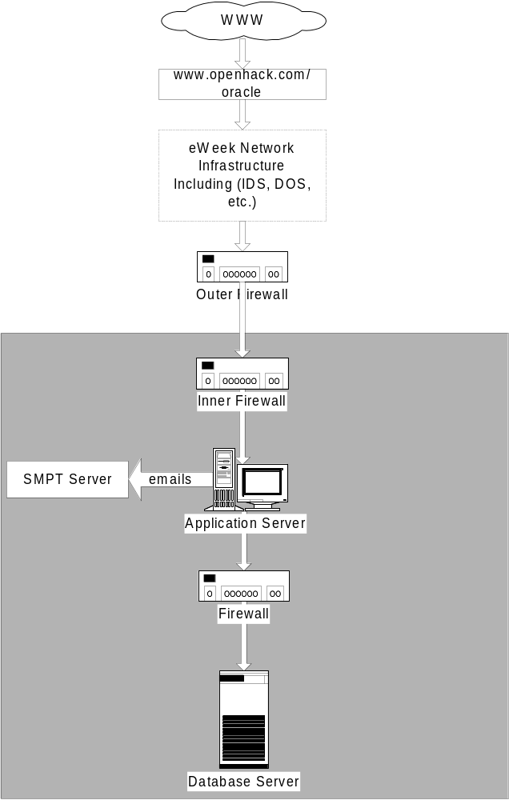
Figure 2

Oracle Software Components Required

The following are Oracle products required for the solution and hardening information:
Oracle9iAS R2 (Application Server)
The following is the specific install information for Oracle9iAS R2 for LINUX (Part Number A91825-01)
- Install Oracle9iAS R2 “Core” components, HTTPD and OC4J.
- Install Security Alerts #36
- Install Security Alerts #37
- Install Security Alerts #41 and review the URL http://otn.oracle.com/deploy/security/alerts.htm
Oracle9i RDBMS R2 (Database Server)
The following is the specific install information for Oracle9i RDBMS R2 for Linux (Part Number A99339-01).
- Install Oracle9i RDBMS “Core” components
- Apply the following Patches/Workarounds
- Install Security Alerts #33 (Database Server)
- Install Security Alerts #38 (Database Server)
- Install Security Alerts #40 (Database Server) and review the URL http://otn.oracle.com/deploy/security/alerts.htm
- Create default database as shipped with the database product.
- Extend the USERS Tablespace (alter tablespace add datafile /<directory>/user02.dbf’ size 200MB).

